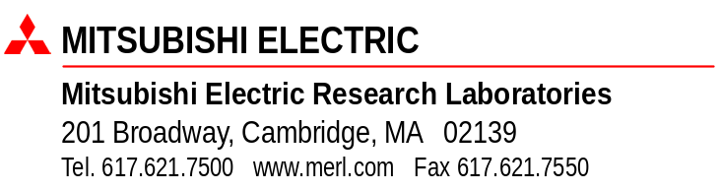
27 May 2004
Jingxian Wu
601 S Providence Road
Unit 603G
Columbia, MO 65203
Dear Jingxian:
We are pleased to offer you an internship at MERL Technology Lab, for the period from 14 June through 17 September 2004. The salary we offer is $29.00 per hour, not to exceed 40 hours per week. MERL’s payroll is generated on a semi-monthly basis (on the 15th and last business day of each month). You will be compensated upon submission of your authorized time sheet.
Since you will not be a permanent employee of MERL, you will not be eligible for company benefits, nor will you be paid for vacation time or other time taken off.
Enclosed is a copy of our Intellectual Property agreement. Please read it carefully and bring it with you on your first day at MERL. We will ask you to sign the agreement here so someone at the lab can witness your signature. You and your host researcher will be able to modify the project description if necessary.
Per government regulations, we are required to have proof of identity and documentation supporting your eligibility to work in the United States. This should be provided within the first three days of your start date.
Meanwhile, if you decide to accept our offer, please sign a copy of this letter and return it to us by 4 June 2004.
We look forward to your being a member of our lab. If you have any questions, please feel free to contact your host Neelesh Mehta (617) 621-7597, Janet O’Halloran (617) 621 7565, Human Resources Manager or Karen Dickie (617) 621 7511, Intern Coordinator.
Sincerely,

Kent Wittenburg, PhD
V P and Director, MERL Technology Lab
I accept MERL’s offer of a 2004 internship.

__________________________________ ________________ 2004 ______________ 2004
Jingxian Wu Date Start Date

